Je m’appelle: ________________________________________ La date: __________________________________________________________________
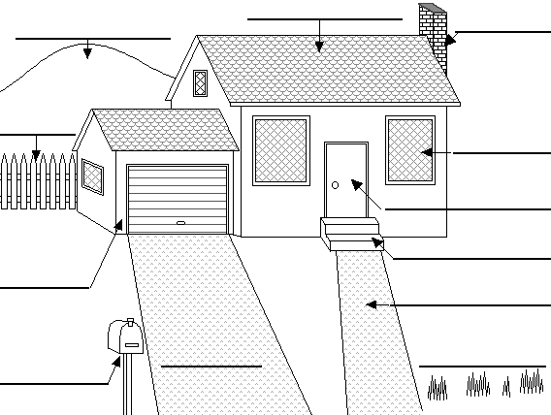
La Maison

le toit
le garage
la porte
la pelouse
la colline
la cheminée
la cloture
la fenêtre
l'allée (f.)
l’allée privée (f.)
la boîte aux lettres
les fleurs
les marches

