YEAR 5 & 6 30th March 2019
LO | To use the language of ratio.
Good | I can write ‘for every… there are…’ sentences to describe the relationship between groups of objects with two different components.
Better | I can describe groups of objects with more than two components using the language of ratio.
Best | I can solve money and coins questions linked to ratio.
I worked independently |  | I worked with a partner | I worked with an adult.

Ratio is a way of comparing one group of objects, or one quantity, with another. We often use them when we are sharing things out (“One for your, two for me!”) or if we are making something (eg: for smoothies you will need 1 part apple juice to 2 parts orange juice, or 5 raspberries for every strawberry).
To start with, write ‘for every _____ there are _____’ sentences to describe the groups below. If you want to use physical objects, you could use different shapes of pasta to support you.
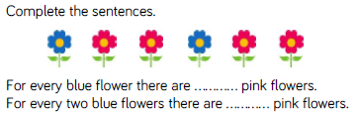

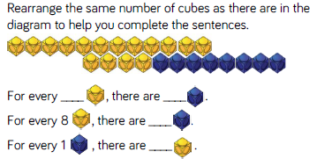

CHALLENGE 1
Answer this question, then make your own group of objects to explore.
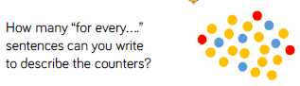

Eg: For every 3 red counters there are five blue counters.
CHALLENGE 2
Answer the following questions.
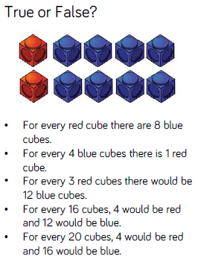

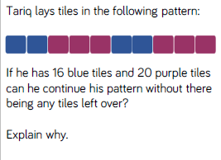
CHALLENGE 3
