YEAR 56 31st March 2020
LO | To notice the link between fractions of quantities and the language of ratio.
Good | I can use the language of ratio to describe groups of objects.
Better | I can compare fractions with the language of ratio and identify errors.
Best | I can compare the answers when asked to find a ratio, or a fraction of a quantity.
I worked independently |  | I worked with a partner | I worked with an adult.

There is a link between ratios and fractions, but you have to be careful.

With this group, you can say, “For every 4 triangles, there are 3 ovals.” This is the same as a ratio. You are comparing the triangles to the ovals.
You can also write 4 out of 7 of the shapes are triangles. This is more like a fraction, which you can write like this 4/7 of the shapes are triangles. With the fraction you are comparing the triangles to how many shapes there are in total.
For all of the challenges below, it would help you to represent the problem in some way using concrete resources: you could use tiddlywinks, bits of pasta, coins, etc.
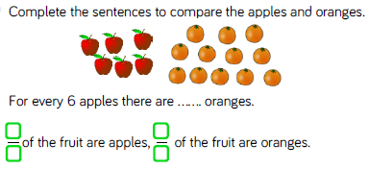
CHALLENGE 1
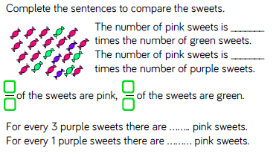

CHALLENGE 2
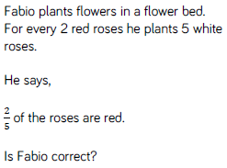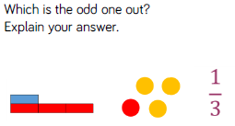
Is there are way to argue that each one is the odd one out?

CHALLENGE 3
