YEAR 56 1st April 2020
LO | To use the ratio symbol to compare groups of objects.
Good | I can use the ratio symbol to describe the relationship between groups of objects. I can simplify ratios.
Better | I can describe the relationship between objects using ratios and fractions.
Best | I can solve problems that require the use of ratios.
I worked independently |  | I worked with a partner | I worked with an adult.

The ratio symbol is like a colon :

So, you can say the ratio of triangles to ovals is 4:3 (We would say, “Four to three.”)
You can also reverse it. So you can say the ratio of ovals to triangles is 3:4
You can also simplify ratios. So, in the picture below, there are now 8 triangles and 6 ovals, the ratio is 8:6 which can be simplified to 4:3

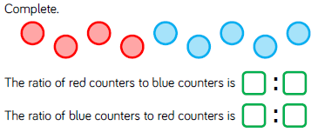
Before you try the challenges, work through the powerpoint.
This might take you the rest of the lesson. If you still have time, you can attempt the challenges below.

CHALLENGE 1
Describe the relationships between quantities, using ratios
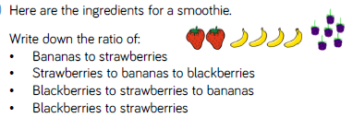
How many of each ingredient would be needed for 2 smoothies?
What would be needed for 5 smoothies?
10 smoothies?

CHALLENGE 2
