CHALLENGE 3
I can investigate the relationship between volume and surface area. I can express my findings through tables and graphs.
The challenge is to arrange them in a 3 by 3 grid like the one below:
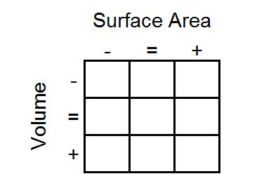
As you go from left to right, the surface area of the shapes must increase.
As you go from top to bottom, the volume of the shapes must increase.
All the cuboids in the middle column must have the same surface area.
All the cuboids on the middle row must have the same volume.
What reasoning can you use to help you to decide where each cuboid must go?
Once you've placed the nine cards, take a look at the extended grid below:
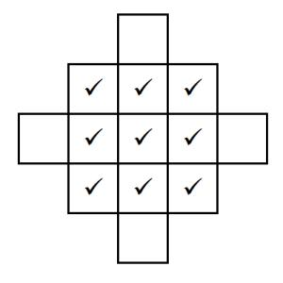
The ticks represent the nine cards you've already placed. Can you create cards with dimensions for cuboids that could go in the four blank spaces that satisfy the same criteria?
Can you design a set of cards of your own with a different cuboid in the centre?

