YEAR 56 2nd April 2020
LO | To calculate ratio and use ratio to solve part-part-whole questions
Good | I can draw a bar model to show a ratio.
Better | I can use a bar model to find the answer to part-part-whole questions using ratio.
Best | I can use ratio to scale up and down and to find missing parts.
I worked independently |  | I worked with a partner | I worked with an adult.

Ratios are used all the time by people working. Builders, engineers, bakers, brewers, carpenters, plumbers, chefs and many other people will use a ratio to know how much of something they need to use.
Ratios can be ‘scaled up.’ This is a bit like finding equivalent fractions – whatever you do to one side, you have to do exactly the same to the other side (multiplication and division only).
For example, a painter knows that he can make orange paint using yellow and red at a ratio of 2 parts red to 3 parts yellow (2:3). If he does exactly the same to each side, he can make sure he always ends up with exactly the same shade of orange.
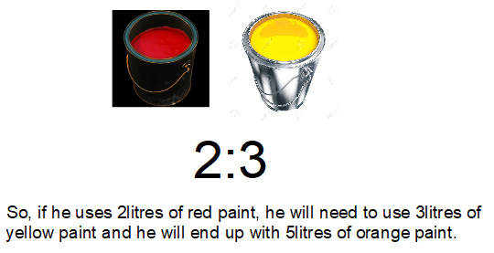
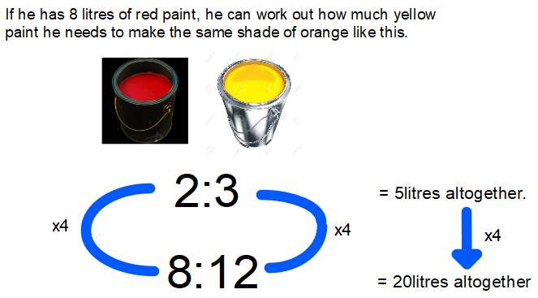
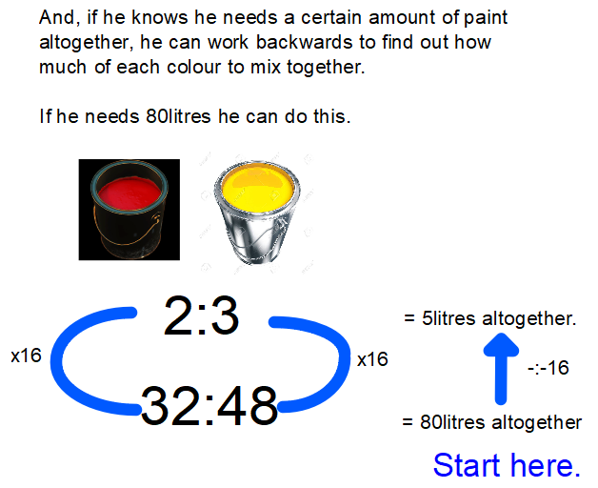

Try this problem, then work your way through one of the challenge sheets. There are three to choose from, so aim for the one you feel best suits your level. The answers are on the back, but don’t look at them until you have finished and you are going through it with your parents. For each of these questions, it might help you to draw diagrams of it, or use counters. Good luck.
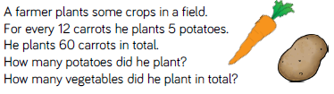

BONUS CHALLENGES
If you are still keen and eager to carry on after you have finished the challenge sheet, you can try these bonus challenges.
CHALLENGE 1
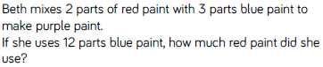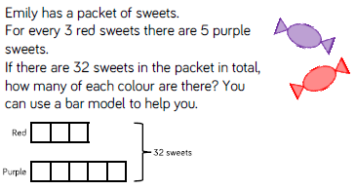

CHALLENGE 2
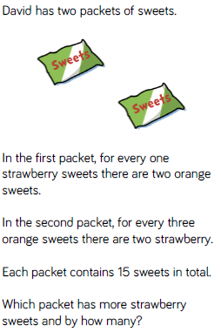

CHALLENGE 3
