The Bronze Age

Facts
The Bronze Age refers to a period of time during which the predominant (also means main) metal employed by a culture was bronze. It usually succeeds the Stone Age and the Copper Age and is followed to the Iron Age. The Bronze Age starts and ends c. 3500 to 1000 b.c but it is onset occurred at different times in different parts of the world. During this period, progress sprang up in Egypt, Hwang Ho Valley in China, on the Aegean Islands of the Mediterranean, and in the Indus Valley. People learnt to grow crops and domesticate animals, so no longer needed to move to find food. This gave them more time to learn how to use metals. Bronze was formed by melting copper and tin together they found this was harder and last longer than the other metals. They used it to make weapons and ornaments and luxury items like jewellery.

Writing and the wheel
The earliest form of writing was called cuneiform started during the Bronze Age. It was invented by the sumeriams. Sumerians where first to make the wheel, wheels where used on wagons and war chariots, and to make pottery.
More Facts
Like the Stone Age the Bronze Age is where the people made tools except they where made of Bronze. Some things that the Bronze Age people made are still here today.

What does Bronze feel like?
Bronze is a fairly soft piece of metal. But after melted tin is added it is much harder. Copper was good for carving and decorating things with and a handy tool for other things. Amazingly not all the world had Copper and tin.

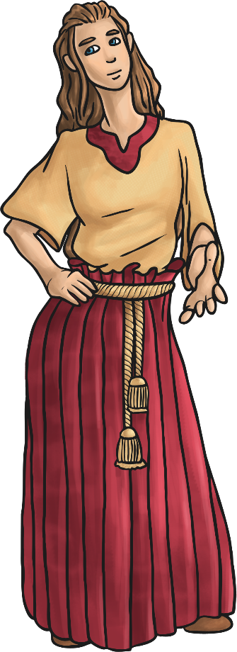
Here is the time line of the Bronze Age:

