KEY QUESTION: What do henges teach us about Stone Age beliefs?
EVIDENCE | PICTURE | WHAT CAN WE INFER ABOUT STONE AGE PEOPLE’S BELIEFS
Ditches were dug around henges. | 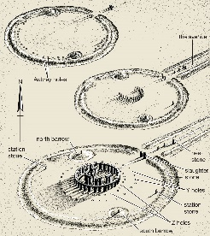 | The ditches aren’t deep enough for defence, so maybe they were just to show where the boundary of the ‘sacred’ site was. Maybe only certain people were allowed inside the boundary, or maybe special clothes had to be worn when people were inside the boundary.
Henges can be found across the British Isles and in parts of Europe. | 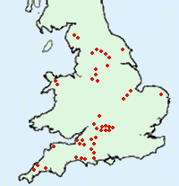
People started farming at about the same time the henges were built | 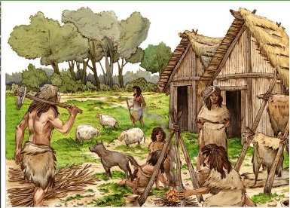
Henges are circles | 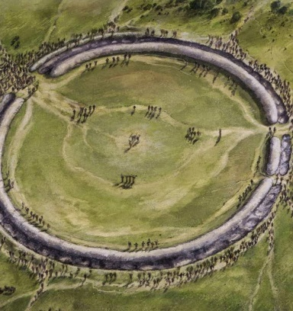
Some henges were made using stones that had been carried for hundreds of miles. | 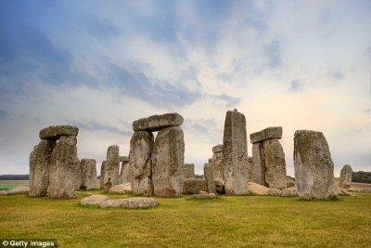
It took a huge effort and thousands of people working together to make a henge | 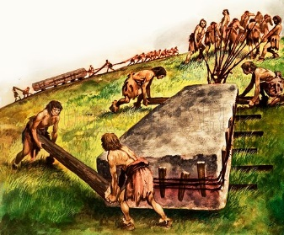
Placing stones on top of each other took great skill and complicated technology | 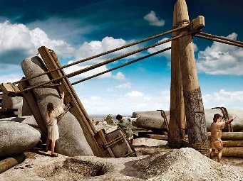
Some henges seem to be lined up with the sun on the solstices (the longest and shortest days) | 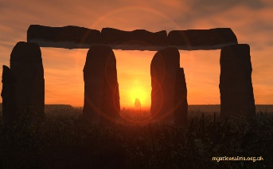
There are lots of burial mounds near Stonehenge | 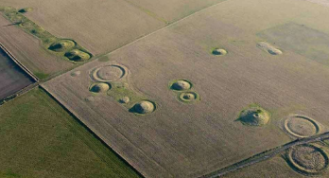
A skeleton with marks of being sacrificed was found at Stonehenge. | 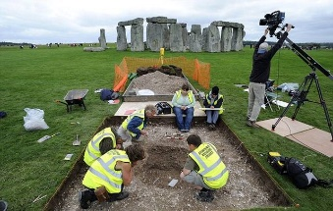
200 bodies were found cremated in the Aubrey holes at Stonehenge | 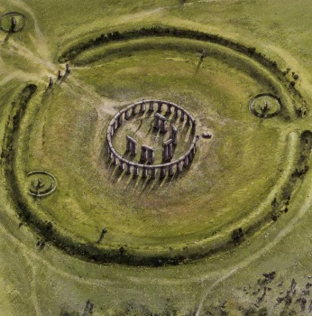
The blue stones might have ‘special sound qualities’ | 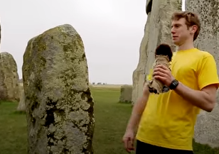
Other evidence

What do you think henges were for?

