SAVE THE ZOOS!
By Ruby Clark, RubyReport.Newstoday@mail.com
Banham Zoo and Africa Alive may have to close due to the lack of income over the past three months caused by Covid-19 and the lockdown.
Banham Zoo and Africa Alive are two much-loved zoos struggling to keep their doors open. The government have rejected them for help. Many zoos are beginning to open, but some zoos cannot open as they are struggling with the current measures in place. Or do not have enough money to buy lots of hand sanitizers and feed the animals at the same time.
If the zoos do collapse, there will not be any school trips so pupils may never get to go to a zoo until they are older and may not discover what happens in a zoo. Plus, tourists often come to zoos but if we have no zoos in our area, tourists will not come to our scenic countryside we have to offer.
Local people are cycling 100 miles through out July to raise money, to support the zoos.
The people who are cycling want to help because the zoos could collapse and lots of jobs will be lost and the animals might have to move to another zoo which would be a shame for us not to see the animals.
Congo Class, Fressingfield schoolgirl, Lily Ferrier is helping both zoos. We had a look on her Just Giving page and here is what she said:
“I am going to cycle 100 miles through July for The Zoological Society of East Anglia - Banham Zoo & Africa Alive because they need to raise funds to help feed the animals,”
So far, she has raised 355 pounds by twenty-four supporters, and she wanted to raise £200 and she has already beaten her goal. You can still donate at https://www.justgiving.com/fundraising/VickyFerrier1?utm_campaign=lc_frp_share transaction_tronal_--_page_launansacti
So, keep your eyes out for those budding young cyclists across July.

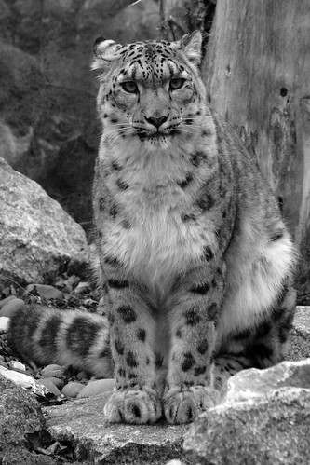

This leopard could have to move to another zoo because her old zoo might collapse.

