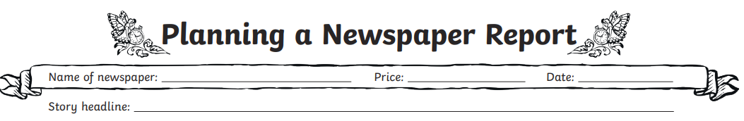
Below are your ideas for your first paragraph, which summarises the fire at Must Farm.
Remember, you can use your imagination and embellish the truth, as many newspapers want to entertain people as well as inform them. So, make this event sound dramatic! Use language to engage and excite the reader!
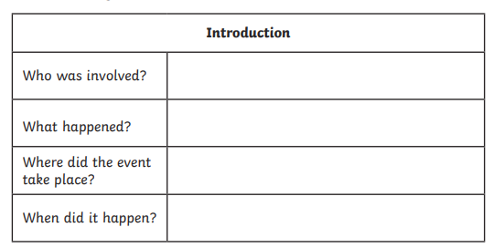
In the next 2 or 3 paragraphs, you need to wind back and tell the story, adding plenty of detail. Use your ideas above as starters. Remember, you can ask to watch a YouTube video of a burning building, to remind you of the sights, sounds and smells.

In the next paragraph, you can add your eye-witness accounts, remembering to use inverted commas for speech. Use your planning guide to remind yourself about detail.
Final paragraph. Here you might want to add a bit of extra detail, or add some rhetorical questions to keep the reader thinking. Maybe more witnesses are needed?

