20th July 2020

Dear Congo Class,
What a year we have had! Lockdown, soap and home-schooling. First, I want to thank my voters for voting for me to be a school councillor and we achieved something together, SOAP DISPENSERS!
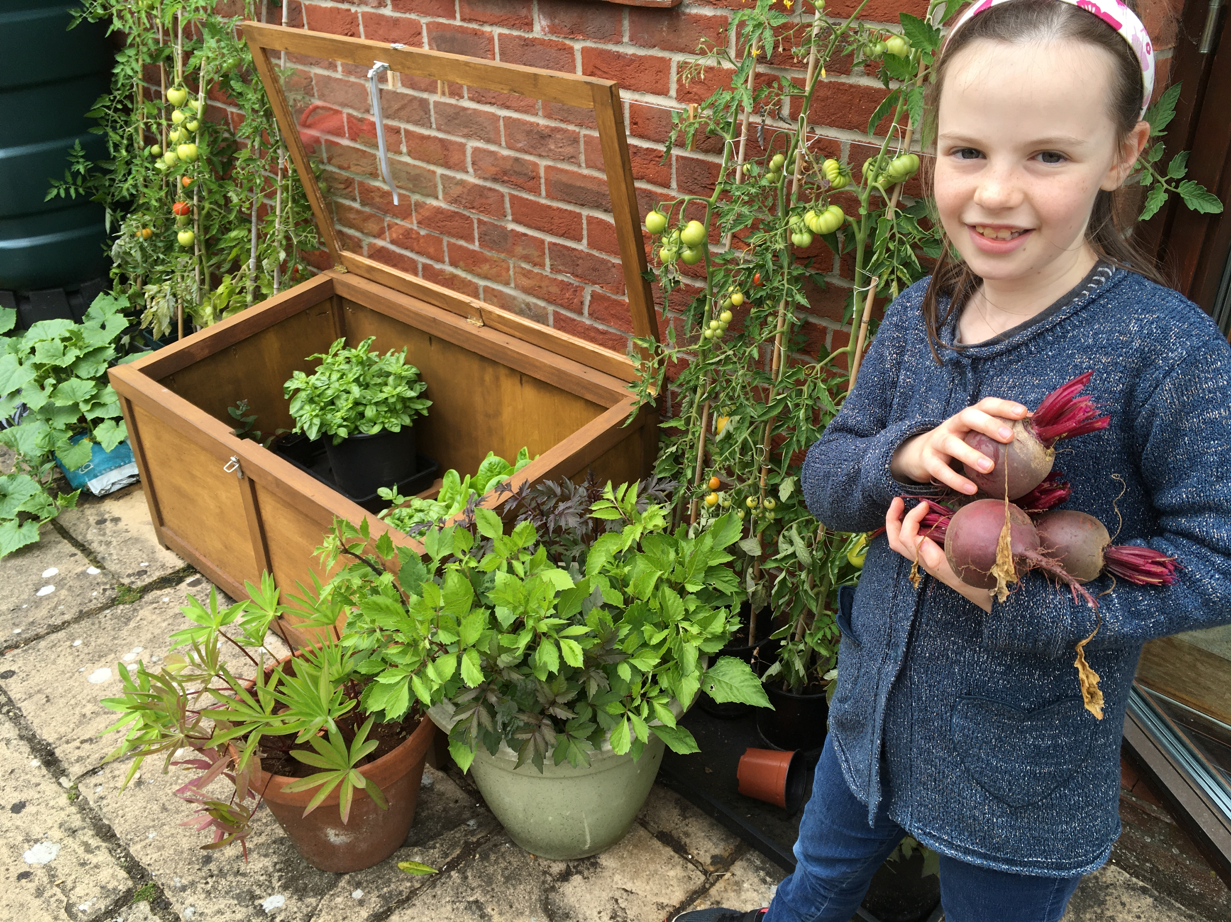
We were all settled in and then BANG, we could not go to school but then we had to home-school, lucky key-worker children. So, home-schooling began lots of hard Maths and English every day! At home gardening club, I grew beetroot, lupins and tomatoes.
On the first home-schooling day, we woke up at our usual time. Then, work began after a chat with my mum to get me started. The first thing I did was writing out my spellings three times. Next, I did my quick maths I got two wrong for my first go, not too bad. Imagine doing one of these EVERYDAY!
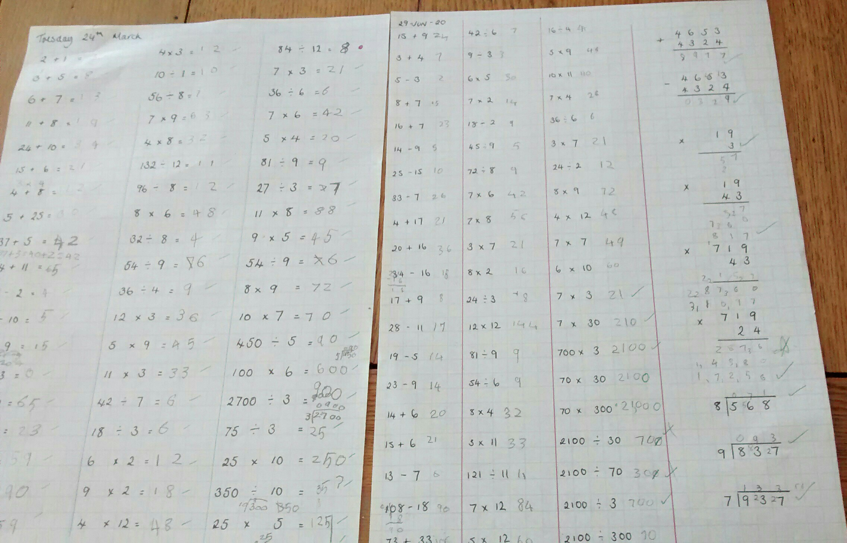
Then it was time for English about direct speech. BREAK TIME!!! Quick kick around with my brother Jacob. Then I did some adding in maths. LUNCH and a quick one-mile walk. French was next so I did food in French. Guided reading was last so I read chapter one of The Borrowers by Mary Norton. This might sound so detailed, that’s because I’m looking at my book😉
Next year, I have got Mr Leicester, but I have a problem I can’t spell his name. Oops!!! I’m very excited for next year as it was fun the week I came in, though I don’t really want to hear his jokes!
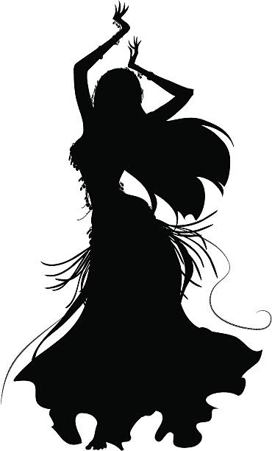
LITTLE STARS might be putting a production on next year of SINGIN’ IN THE RAIN starring me!
I really want to see you.
From
Ruby 
PS-I hope to see you soon and I have a new look 😊😊😊

