**Developing 1: To use short division to divide 3-digit numbers**

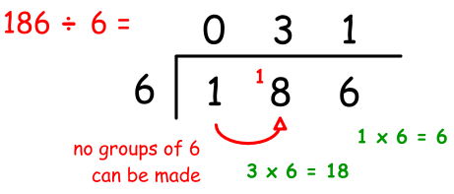

1. 366 **÷** 3 = 6. 688 **÷** 4 =

2. 568 **÷** 4 = 7. 744 **÷** 3 =

3. 236 **÷** 3 = 8. 272 **÷** 4 =

4. 476 **÷** 4 = 9. 696 **÷** 6 =

5. 675 **÷** 5 = 10. 228 **÷** 4 =

**Developing 1: To use short division to divide 3-digit numbers**



1. 366 **÷** 3 = 6. 688 **÷** 4 =

2. 568 **÷** 4 = 7. 744 **÷** 3 =

3. 236 **÷** 3 = 8. 272 **÷** 4 =

4. 476 **÷** 4 = 9. 696 **÷** 6 =

5. 675 **÷** 5 = 10. 228 **÷** 4 =

**Developing 1: To use short division to divide 3-digit numbers**



1. 366 **÷** 3 = 6. 688 **÷** 4 =

2. 568 **÷** 4 = 7. 744 **÷** 3 =

3. 236 **÷** 3 = 8. 272 **÷** 4 =

4. 476 **÷** 4 = 9. 696 **÷** 6 =

5. 675 **÷** 5 = 10. 228 **÷** 4 =

**Developing 1: To use short division to divide 3-digit numbers**



1. 366 **÷** 3 = 6. 688 **÷** 4 =

2. 568 **÷** 4 = 7. 744 **÷** 3 =

3. 236 **÷** 3 = 8. 272 **÷** 4 =

4. 476 **÷** 4 = 9. 696 **÷** 6 =

5. 675 **÷** 5 = 10. 228 **÷** 4 =

**Developing 1: To use short division to divide 3-digit numbers**



1. 366 **÷** 3 = 6. 688 **÷** 4 =

2. 568 **÷** 4 = 7. 744 **÷** 3 =

3. 236 **÷** 3 = 8. 272 **÷** 4 =

4. 476 **÷** 4 = 9. 696 **÷** 6 =

5. 675 **÷** 5 = 10. 228 **÷** 4 =

**Developing 1: To use short division to divide 3-digit numbers**



1. 366 **÷** 3 = 6. 688 **÷** 4 =

2. 568 **÷** 4 = 7. 744 **÷** 3 =

3. 236 **÷** 3 = 8. 272 **÷** 4 =

4. 476 **÷** 4 = 9. 696 **÷** 6 =

5. 675 **÷** 5 = 10. 228 **÷** 4 =

**Developing 2: To use short division to divide 3-digit numbers**



1. 366 **÷** 6 = 6. 469 **÷** 7 =

2. 427 **÷** 7 = 7. 576 **÷** 6 =

3. 546 **÷** 6 = 8. 371 **÷** 7 =

4. 735 **÷** 7 = 9. 438 **÷** 6 =

5. 672 **÷** 6 = 10. 532 **÷** 7 =

**Developing 2: To use short division to divide 3-digit numbers**



1. 366 **÷** 6 = 6. 469 **÷** 7 =

2. 427 **÷** 7 = 7. 576 **÷** 6 =

3. 546 **÷** 6 = 8. 371 **÷** 7 =

4. 735 **÷** 7 = 9. 438 **÷** 6 =

5. 672 **÷** 6 = 10. 532 **÷** 7 =

**Developing 2: To use short division to divide 3-digit numbers**



1. 366 **÷** 6 = 6. 469 **÷** 7 =

2. 427 **÷** 7 = 7. 576 **÷** 6 =

3. 546 **÷** 6 = 8. 371 **÷** 7 =

4. 735 **÷** 7 = 9. 438 **÷** 6 =

5. 672 **÷** 6 = 10. 532 **÷** 7 =

**Developing 2: To use short division to divide 3-digit numbers**



1. 366 **÷** 6 = 6. 469 **÷** 7 =

2. 427 **÷** 7 = 7. 576 **÷** 6 =

3. 546 **÷** 6 = 8. 371 **÷** 7 =

4. 735 **÷** 7 = 9. 438 **÷** 6 =

5. 672 **÷** 6 = 10. 532 **÷** 7 =

**Developing 2: To use short division to divide 3-digit numbers**



1. 366 **÷** 6 = 6. 469 **÷** 7 =

2. 427 **÷** 7 = 7. 576 **÷** 6 =

3. 546 **÷** 6 = 8. 371 **÷** 7 =

4. 735 **÷** 7 = 9. 438 **÷** 6 =

5. 672 **÷** 6 = 10. 532 **÷** 7 =

**Developing 2: To use short division to divide 3-digit numbers**



1. 366 **÷** 6 = 6. 469 **÷** 7 =

2. 427 **÷** 7 = 7. 576 **÷** 6 =

3. 546 **÷** 6 = 8. 371 **÷** 7 =

4. 735 **÷** 7 = 9. 438 **÷** 6 =

5. 672 **÷** 6 = 10. 532 **÷** 7 =

**Mastery: To explain mistakes in calculations using short division**

Jamie is using short division to divide 3-digit numbers.

He has done these calculations but he isn’t sure if they are right. You need to check them for him.

You will need to **fully** **explain any mistakes** you find so Jamie can know what he will need to do next time.

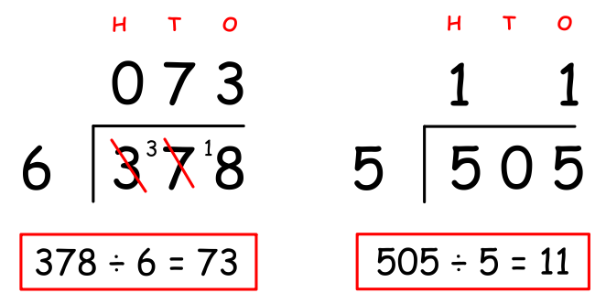 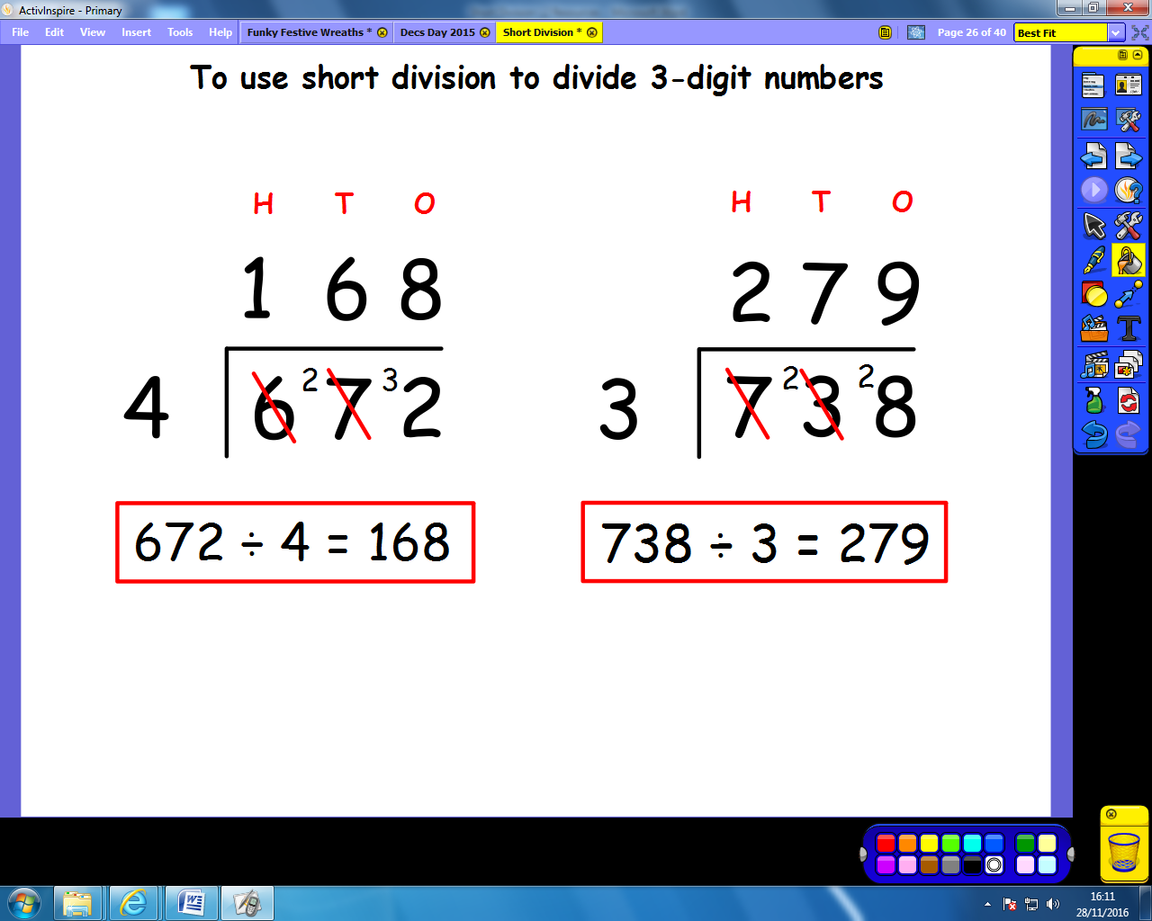

**Key Vocabulary**: hundreds, tens, ones, column, groups of, exchanged, place value, place holder, quotient

**Mastery: To explain mistakes in calculations using short division**

Jamie is using short division to divide 3-digit numbers.

He has done these calculations but he isn’t sure if they are right. You need to check them for him.

You will need to **fully** **explain any mistakes** you find so Jamie can know what he will need to do next time.

 

**Key Vocabulary**: hundreds, tens, ones, column, groups of, exchanged, place value, place holder, quotient

**Mastery: To explain mistakes in calculations using short division**

Jamie is using short division to divide 3-digit numbers.

He has done these calculations but he isn’t sure if they are right. You need to check them for him.

You will need to **fully** **explain any mistakes** you find so Jamie can know what he will need to do next time.

 

**Key Vocabulary**: hundreds, tens, ones, column, groups of, exchanged, place value, place holder, quotient

**Greater Depth:** [1]

54 **÷** 6 = 9

dividend **÷** divisor = quotient

When you half the divisor it doubles the quotient.

Is this always, sometimes, or never true?

Investigate and prove your answer with examples.

**Greater Depth:** [1]

54 **÷** 6 = 9

dividend **÷** divisor = quotient

When you half the divisor it doubles the quotient.

Is this always, sometimes, or never true?

Investigate and prove your answer with examples.

**Greater Depth:** [1]

54 **÷** 6 = 9

dividend **÷** divisor = quotient

When you half the divisor it doubles the quotient.

Is this always, sometimes, or never true?

Investigate and prove your answer with examples.

**Greater Depth:** [1]

54 **÷** 6 = 9

dividend **÷** divisor = quotient

When you half the divisor it doubles the quotient.

Is this always, sometimes, or never true?

Investigate and prove your answer with examples.

**Greater Depth:** [1]

54 **÷** 6 = 9

dividend **÷** divisor = quotient

When you half the divisor it doubles the quotient.

Is this always, sometimes, or never true?

Investigate and prove your answer with examples.

**Greater Depth:** [1]

54 **÷** 6 = 9

dividend **÷** divisor = quotient

When you half the divisor it doubles the quotient.

Is this always, sometimes, or never true?

Investigate and prove your answer with examples.

**Greater Depth:** [1]

54 **÷** 6 = 9

dividend **÷** divisor = quotient

When you half the divisor it doubles the quotient.

Is this always, sometimes, or never true?

Investigate and prove your answer with examples.

**Greater Depth:** [1]

54 **÷** 6 = 9

dividend **÷** divisor = quotient

When you half the divisor it doubles the quotient.

Is this always, sometimes, or never true?

Investigate and prove your answer with examples.

**Greater Depth:** [1]

54 **÷** 6 = 9

dividend **÷** divisor = quotient

When you half the divisor it doubles the quotient.

Is this always, sometimes, or never true?

Investigate and prove your answer with examples.

**Greater Depth:** [1]

54 **÷** 6 = 9

dividend **÷** divisor = quotient

When you half the divisor it doubles the quotient.

Is this always, sometimes, or never true?

Investigate and prove your answer with examples.

**Greater Depth:** [2]

The sum of four even numbers is always divisible by four (without leaving remainders).

Is this always, sometimes or never true?

Investigate and **prove your answer with examples**.

**Greater Depth:** [2]

The sum of four even numbers is always divisible by four (without leaving remainders).

Is this always, sometimes or never true?

Investigate and **prove your answer with examples**.

**Greater Depth:** [2]

The sum of four even numbers is always divisible by four (without leaving remainders).

Is this always, sometimes or never true?

Investigate and **prove your answer with examples**.

**Greater Depth:** [2]

The sum of four even numbers is always divisible by four (without leaving remainders).

Is this always, sometimes or never true?

Investigate and **prove your answer with examples**.

**Greater Depth:** [2]

The sum of four even numbers is always divisible by four (without leaving remainders).

Is this always, sometimes or never true?

Investigate and **prove your answer with examples**.

**Greater Depth:** [2]

The sum of four even numbers is always divisible by four (without leaving remainders).

Is this always, sometimes or never true?

Investigate and **prove your answer with examples**.

**Greater Depth:** [2]

The sum of four even numbers is always divisible by four (without leaving remainders).

Is this always, sometimes or never true?

Investigate and **prove your answer with examples**.

**Greater Depth:** [2]

The sum of four even numbers is always divisible by four (without leaving remainders).

Is this always, sometimes or never true?

Investigate and **prove your answer with examples**.

**Greater Depth:** [2]

The sum of four even numbers is always divisible by four (without leaving remainders).

Is this always, sometimes or never true?

Investigate and **prove your answer with examples**.

**Greater Depth:** [2]

The sum of four even numbers is always divisible by four (without leaving remainders).

Is this always, sometimes or never true?

Investigate and **prove your answer with examples**.

**Greater Depth:** [2]

The sum of four even numbers is always divisible by four (without leaving remainders).

Is this always, sometimes or never true?

Investigate and **prove your answer with examples**.

**Greater Depth:** [2]

The sum of four even numbers is always divisible by four (without leaving remainders).

Is this always, sometimes or never true?

Investigate and **prove your answer with examples**.

**Greater Depth:** [2]

The sum of four even numbers is always divisible by four (without leaving remainders).

Is this always, sometimes or never true?

Investigate and **prove your answer with examples**.

**Greater Depth:** [2]

The sum of four even numbers is always divisible by four (without leaving remainders).

Is this always, sometimes or never true?

Investigate and **prove your answer with examples**.