Developing:

L.O. To use short division to divide 2-digit numbers
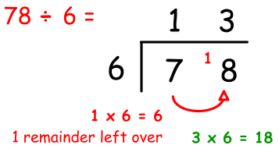

1. 96 ÷ 6 = 7. 68 ÷ 4 =
2. 69 ÷ 3 = 8. 85 ÷ 5 =
3. 84 ÷ 6 = 9. 98 ÷ 7 =
4. 84 ÷ 7 = 10. 78 ÷ 3 =
5. 54 ÷ 3 = 11. 92 ÷ 4 =
6. 52 ÷ 4 = 12. 96 ÷ 8 =
Developing:

L.O. To use short division to divide 2-digit numbers

1. 96 ÷ 6 = 7. 68 ÷ 4 =
2. 69 ÷ 3 = 8. 85 ÷ 5 =
3. 84 ÷ 6 = 9. 98 ÷ 7 =
4. 84 ÷ 7 = 10. 78 ÷ 3 =
5. 54 ÷ 3 = 11. 92 ÷ 4 =
6. 52 ÷ 4 = 12. 96 ÷ 8 =
Developing:

L.O. To use short division to divide 2-digit numbers

1. 96 ÷ 6 = 7. 68 ÷ 4 =
2. 69 ÷ 3 = 8. 85 ÷ 5 =
3. 84 ÷ 6 = 9. 98 ÷ 7 =
4. 84 ÷ 7 = 10. 78 ÷ 3 =
5. 54 ÷ 3 = 11. 92 ÷ 4 =
6. 52 ÷ 4 = 12. 96 ÷ 8 =
Developing:

L.O. To use short division to divide 2-digit numbers

1. 96 ÷ 6 = 7. 68 ÷ 4 =
2. 69 ÷ 3 = 8. 85 ÷ 5 =
3. 84 ÷ 6 = 9. 98 ÷ 7 =
4. 84 ÷ 7 = 10. 78 ÷ 3 =
5. 54 ÷ 3 = 11. 92 ÷ 4 =
6. 52 ÷ 4 = 12. 96 ÷ 8 =

Mastery:

To use short division to find missing values

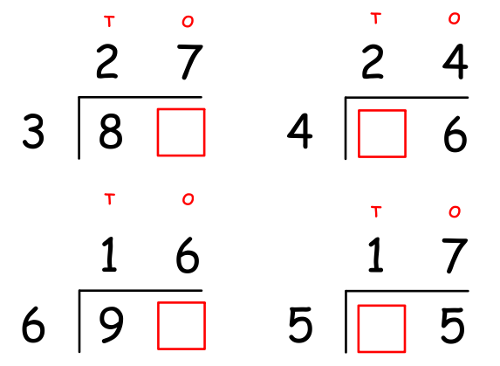

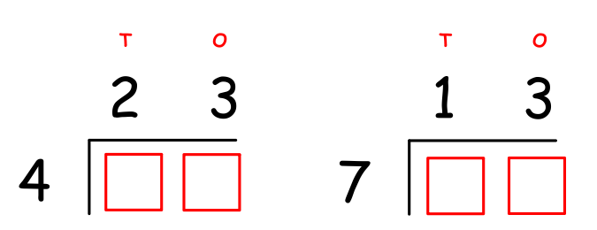

Mastery:

To use short division to find missing values

Mastery:

To use short division to find missing values

Mastery:

To use short division to find missing values

Greater Depth: [1]

24 ÷ 6 = ______
48 ÷ 6 = ______
96 ÷ 6 = ______

1. How are these calculations linked?
1. What pattern do you spot? Explain.

2. Can you create a rule?

3. Test your rule using your own examples.

dividend ÷ divisor = quotient

Greater Depth: [1]

24 ÷ 6 = ______
48 ÷ 6 = ______
96 ÷ 6 = ______

1. How are these calculations linked?
1. What pattern do you spot? Explain.

2. Can you create a rule?

3. Test your rule using your own examples.

dividend ÷ divisor = quotient

Greater Depth: [1]

24 ÷ 6 = ______
48 ÷ 6 = ______
96 ÷ 6 = ______

1. How are these calculations linked?
1. What pattern do you spot? Explain.

2. Can you create a rule?

3. Test your rule using your own examples.

dividend ÷ divisor = quotient

Greater Depth: [1]

24 ÷ 6 = ______
48 ÷ 6 = ______
96 ÷ 6 = ______

1. How are these calculations linked?
1. What pattern do you spot? Explain.

2. Can you create a rule?

3. Test your rule using your own examples.

dividend ÷ divisor = quotient

Greater Depth: [1]

24 ÷ 6 = ______
48 ÷ 6 = ______
96 ÷ 6 = ______

1. How are these calculations linked?
1. What pattern do you spot? Explain.

2. Can you create a rule?

3. Test your rule using your own examples.

dividend ÷ divisor = quotient

Greater Depth: [1]

24 ÷ 6 = ______
48 ÷ 6 = ______
96 ÷ 6 = ______

1. How are these calculations linked?
1. What pattern do you spot? Explain.

2. Can you create a rule?

3. Test your rule using your own examples.

dividend ÷ divisor = quotient

Greater Depth: To use short division to investigate how many divisors a number has [2]
Circle the numbers that 96 can divide into without remainders | 2 3 4 5 6 7 8 9 10 11 12
- Why do multiples of 12 have so many divisors? Do all multiples of 12 have these divisors? Explain.

- Find your own 2-digit numbers that have at least 5 divisors.

Greater Depth: To use short division to investigate how many divisors a number has [2]
Circle the numbers that 96 can divide into without remainders | 2 3 4 5 6 7 8 9 10 11 12
- Why do multiples of 12 have so many divisors? Do all multiples of 12 have these divisors? Explain.

- Find your own 2-digit numbers that have at least 5 divisors.

Greater Depth: To use short division to investigate how many divisors a number has [2]
Circle the numbers that 96 can divide into without remainders | 2 3 4 5 6 7 8 9 10 11 12
- Why do multiples of 12 have so many divisors? Do all multiples of 12 have these divisors? Explain.

- Find your own 2-digit numbers that have at least 5 divisors.

Greater Depth: To use short division to investigate how many divisors a number has [2]
Circle the numbers that 96 can divide into without remainders | 2 3 4 5 6 7 8 9 10 11 12
- Why do multiples of 12 have so many divisors? Do all multiples of 12 have these divisors? Explain.

- Find your own 2-digit numbers that have at least 5 divisors.

